How to Sign-up for Uniform Promotional Positions

Step 1: Go to www.dallascityhall.com and select “Employment” and “Internal Positions”. In the Announcement box, links are provided to download/print the “Promotional Examination Announcement” and “Calendar”.

ANNOUNCEMENT
Sign-up for the Uniform Promotional Position is now open. Sign-up is available 24x7 via a secure site on the Internet…follow these links for more information:

- Download and read the Promotional Examination Announcement and Calendar
- Download and follow the instructions in the How To Sign-up document.
- Useful links:
Link to log into/create an account in Neogov: Sign-in NEOGOV
Link to submit an application for the Promotional Exam: Submit Application
- Once you have submitted the brief promotional application, don’t forget to log back in and check your Application Status – it should read “Application Received” if you have successfully signed up.
If you encounter any issues while submitting your application, contact the Civil Service office at 214-670-5915 or in person at 1500 Marilla St., 1C-South. Office hours are 8:15 am – 5:15 pm, Monday – Friday.
If you encounter any issues while submitting your application, contact the Civil Service office at 214-670-5915 or in person at 1500 Marilla St., 1C-South. Office hours are 8:15 am – 5:15 pm, Monday – Friday.

Step 2: Select the Submit Application link in Step 3 of the Announcement box. Locate and click on the title of the Promotional Position. All promotional positions will be displayed alphabetically.

Step 3: On the right-hand side of the page, click on “Apply”.

Step 4a: If you already have a User Account, go to Step 5. If you do not have an account, click on the “Create an account” link and enter the requested information.
Step 4b: Once you are logged into the system, the following page will appear. Click on the Skip this step button to proceed. Go to Step 6.
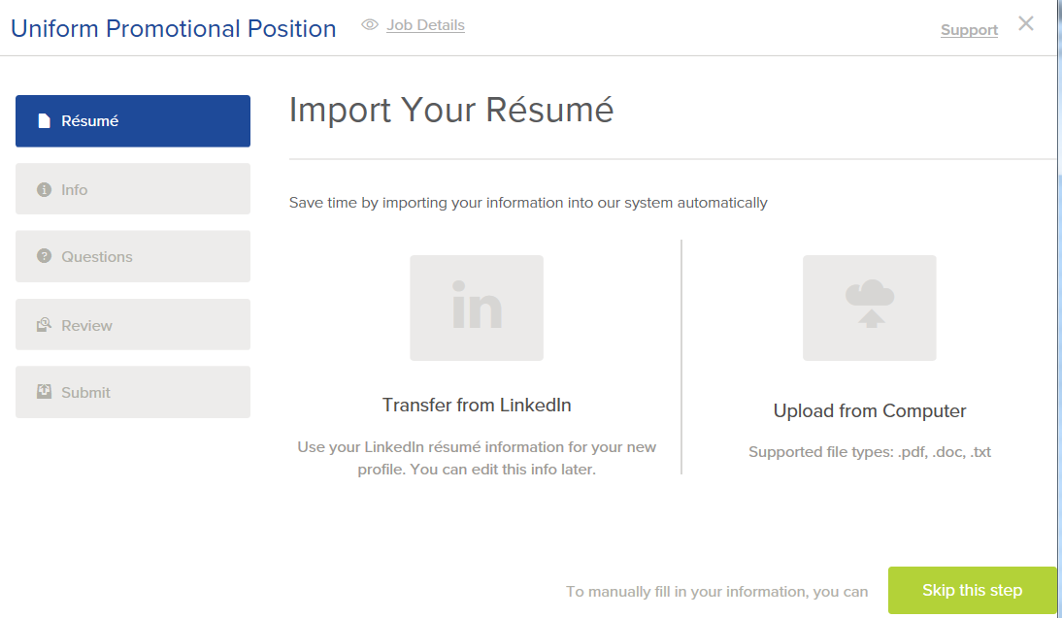

Step 5: If you have an existing User Account, enter your Username and Password and then click on the Sign In button. If you cannot remember your Username or Password, click on the “Forgot Username” and/or “Reset Password” links and follow the instructions provided. Once you are logged into the system go to Step 6.

Step 6 – Contact Information:
- If this is a new account, enter the required information in the “Contact Information” section. When complete, click on the Save button.
- If this is an existing account, review your contact information for accuracy. If the information needs to be updated, click the “Edit” link in the top right corner of the box and make the necessary changes. When complete, click on the Save button.
- If no changes are needed, go to Step 7.

Step 7 – Personal Information:
- If this is a new account, enter the required information in the “Personal Information” section. When complete, click on the Save button.
- If this is an existing account, review your personal information for accuracy. If the information needs to be updated, click the “Edit” link in the top right corner of the box and make the necessary changes. When complete, click on the Save button.
- If no changes are needed, go to Step 8.

Step 8 – Preferences: The information in the “Preferences” section is not required.
- If this is a new account, you will need to click on the Save button even if you do not enter any information.
- If this is an existing account, review your preferences information for accuracy. If you wish to update this information, click the “Edit” link in the top right corner of the box and make the necessary changes. When complete, click on the Save button.
- If no changes are needed, go to Step 9.

Step 9: Click the Next button to proceed.

Step 10a – Agency Questions (Required): Answer questions 1 and 2.

Step 10b – Agency Questions (Optional): Questions 3 to 6 are not required. You may skip these questions.

Step 10c: When you have finished, click on the Proceed to review button at the bottom of the page.

Step 11: On the next screen, review your information for accuracy. If any information needs to be corrected/updated: Click on the “Edit” link for the section that needs to be changed, make the changes and click on the Save button. Once all the information is correct, click on the Proceed to Certify and Submit button at the bottom of the page.

Step 12: On the next screen, read the Certification Statement and click the Accept & Submit button if you agree to the statement. If you select the Decline button, the application will not be submitted to the City of Dallas for consideration (i.e. you will not be signed-up for the promotional exam).

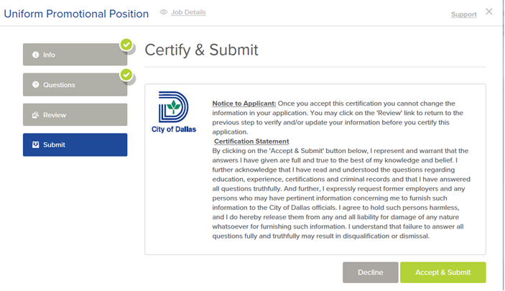

Step 13: Once you accept the statement, a confirmation screen will appear verifying that your application has been received by the City of Dallas. You will also receive an email confirmation from info@governmentjobs.com at the same time.

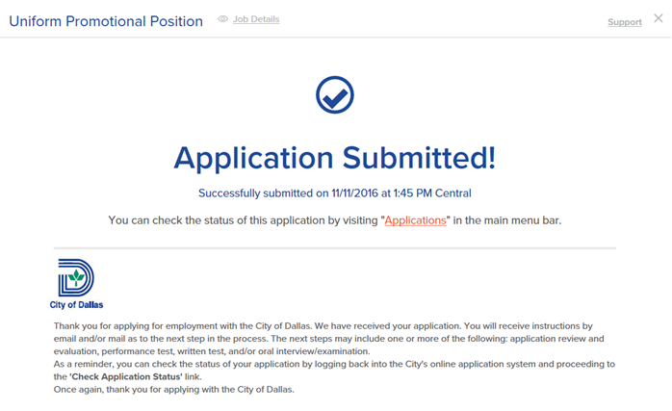

Step 14a: Check the status of your application (e.g., Application Received) by clicking on the “Applications” link on the “Application Submitted page. (See above) OR by clicking the arrow next to your name in the top right-hand corner of the screen and selecting the “Applications” from the menu.
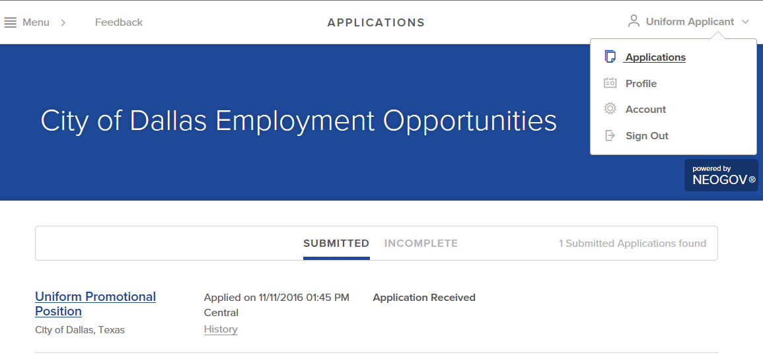

Step 14b: If you have successfully submitted your application, you will see the title of the Uniform Rank/Position, the date/time that you applied and the status (Application Received.) If you do not see the Uniform Rank/Position you are interested in with today’s date in the “Applications” section, YOU DID NOT SUBMIT YOUR APPLICATION and YOU ARE NOT SIGNED-UP FOR THE PROMOTIONAL OPPORTUNITY. You will need to go back through this step process again.

