CITY PLAN COMMISSION THURSDAY, JUNE 22, 2017

Planner: Vasavi Pilla
FILE NUMBER: DCA 156-006 DATE INITIATED: April 7, 2016
TOPIC: Accessory Dwelling Units
CITY COUNCIL DISTRICTS: All CENSUS TRACTS: All

PROPOSAL: Consideration of amending Chapters 51 and 51A of the Dallas Development Code, Section 51-4.201 and Section 51(A)-4.209 to allow the Board of Adjustment to grant a special exception to authorize an additional dwelling unit to be rented, and Section 51-4.500 and Section 51A-4.500 to create regulations for an accessory dwelling unit overlay.
SUMMARY: Staff proposes a two pronged approach: 1) establish a Board of Adjustment (BDA) special exception to authorize an additional dwelling unit as a rental accommodation; and 2) create regulations for an accessory dwelling unit overlay.

ZOAC RECOMMENDATION: No Change

STAFF RECOMMENDATION: Approval

BACKGROUND

- On October 19, 2015, the City Council Housing Committee was briefed on Accessory Dwelling Units. The Housing Committee directed staff to conduct a meeting to gather input on allowing accessory dwelling units and their potential impact on neighbors and neighborhoods.

- On December 15, 2015, staff held a public meeting to receive comments regarding this topic.

- On February 16, 2016, the City Council Housing Committee was again briefed and updated on the input received from the public meeting. The Committee directed staff to proceed to the Zoning Ordinance Advisory Committee (ZOAC).

- Zoning Ordinance Advisory Committee (ZOAC) considered this issue at five public meetings: January 19, 2017; February 16, 2017; March 16, 2017; April 6, 2017 and April 27, 2017.

- On April 27, 2017, ZOAC recommended “no change” to the Dallas Development Code.

GENERAL INFORMATION/STAFF ANALYSIS

An “Accessory Dwelling Unit” or “Granny Flat” is an additional dwelling unit on a single family lot.

Currently, Dallas City Code allows an additional dwelling unit by a special exception granted by the Board of Adjustment (BDA). BDA may grant a special exception to authorize an additional dwelling unit in any district when, in the opinion of the board, the additional dwelling unit will not be used as a rental accommodation (and will be deed restricted as such) and will not adversely affect neighboring properties.

The City Council adopted Neighborhood Plus Plan identifies gaps in affordable housing in the Dallas area. Thirty-one percent (31%) of owners and are 48% of renters are living in homes unaffordable to them. The plan indicates a need for housing choices for those with income below $50,000 per year.

Neighborhood Plus Plan’s recommended policies include:

- Policy 5.1 Encourage a wider range of well-designed and affordable housing types as a response to emerging homeownership preferences.
- Policy 6.2 Expand affordable housing options and encourage its distribution throughout the city and region.

Researching the Index Cities, it was found that many allow accessory dwelling units as a zoning tool. ADUs may be one of the way to increase affordable housing units, increase mixed-income housing options in neighborhoods, allow seniors to remain in their neighbourhood, or provide entry into a specific neighborhood.

STAFF PROPOSAL:

Staff is recommending a two-pronged approach to allow additional dwelling units within Dallas: 1) establish an additional Board of Adjustment (BDA) special exception to authorize an additional dwelling unit as a rental accommodation; and 2) create regulations for an ADU overlay. These options will allow property owners to choose the option that works best for their neighborhood and their circumstances.

- Allow the Board of Adjustment (BDA) to grant a special exception to authorize an additional dwelling unit to be rented
- The board of adjustment may grant a special exception to authorize an additional dwelling unit as a rental accommodation in limited single family districts when:
- the additional rental unit will not adversely affect neighboring properties;
- deed restrict the subject property to require owner occupancy on the premises;
- Board may determine if an additional parking space is required; and
- register the rental property with the Single Family Non-Owner Occupied Rental Program of the City annually.

- Accessory Dwelling Units (ADU) Overlay District:

Establish a process similar to the Neighborhood Stabilization Overlay (NSO) process to create an overlay to allow ADUs.

Process:
- ADU Overlay is allowed over a neighborhood by a neighborhood sponsored application process;
- ADU Overlay is allowed over single family residential districts (A(A), R-1(A), R-1/2(A), R- 5(A), R-7.5 (A), R-10(A), R-16 (A), and R-13(A);
- ADU overlay may also be placed on:
- historic overly district and conservation district: design standards, significant architectural and cultural attributes of the respective district’s will apply,
- neighborhood stabilization overlay district: yard, lot and space regulations of the district will apply,
- only in single family planned development district;
- ADU overlay should include at a minimum 50 single family lots. A district must contain at least 50 single family lots in a compact, contiguous area, or be an entire original subdivision if the subdivision contains fewer than 50 single family lots;
- the boundary lines should be drawn to include blockfaces on both sides of a street and defined by street intersection or natural boundary as the edges of the district. Mid-blockface breaks are not acceptable;
- ADU overlay process:
- ADU overlay neighborhood committee consisting of at least 10 property owners within the proposed overlay area,
- Staff schedules an initial meeting to explain the process;
- Neighborhood committee must provide:
- committee list;
- proposed boundary map and plat;
- city staff generates the petitions and holds a neighborhood meeting;
- Neighborhood committee is responsible for the petition process: gathering the signatures, submitting the petitions to the city and other information the director determines is necessary;
- The application fee ($2,400).
- If a petition is signed by more than 50 percent but less than 75 percent of the lots within the proposed district, the application fee must be paid;
- If a petition is signed by 75 percent or more of the lots within the proposed district, the application fee is waived;
- A public hearing to create a district is initiated by submission of a complete petition.

Proposed Regulations:
- May be Attached or Detached
- If DETACHED:
- cannot be located in front of the main structure;
- minimum of 200 square feet;
- floor area of the structure containing ADU cannot exceed 25 percent of the floor area of the main building;
- height of the structure containing ADU cannot exceed the height of the primary dwelling unit;
- If the height of the structure containing ADU is less than 15 feet and located in the rear 30 percent of the lot, a minimum three foot side yard setback must be provided;
- If the height of the structure containing ADU is less than 15 feet, a minimum three foot rear yard setback must be provided;
- If the height of the structure containing ADU is over 15 feet, setbacks of the zoning district shall be maintained;
- compatible with the main building: similar in color, materials, exterior siding, roofing, roof pitch, foundation fascia, and fenestration;
- Board of Adjustment may grant a variance to allow: (i) ADU in the primary yard; (ii) reduce the setbacks (side yard and rear yard) requirements; and (iii) height.
Note: some of the proposed regulations are similar to the accessory structure regulations.

- If ATTACHED:
- floor area of the structure containing ADU cannot exceed 25 percent of the floor area of the main building (over 26 percent would be considered a duplex).

- Owner occupancy on the premises
- Property owner shall reside on the lot occupying either the primary dwelling unit or the accessory dwelling unit (ADU). The residency is evidenced by voter registration, vehicle registration or other similar acceptable means by the City Attorney’s Office;
- Temporary absence of up to 9 months is allowed, anytime over this can lead to the violation of this regulation.

- Parking Space for ADU
- At least one off-street parking space shall be designated for the ADU. This parking is in addition to the minimum required off-street parking for the single family residence,
- Off-street parking is not required for the ADU if 75% of the property owners approve such parking reduction through the petition process;
- On-street parking cannot be counted towards this requirement. If the garage is converted to an ADU, parking for the single family and the ADU should be shown and approved before getting the building permit.

- Register with Single Family Non-Owner Occupied Rental Program of the City:
- Non-owner occupied unit on the lot (ADU or primary dwelling unit) must be registered under the single family Non-Owner Occupied Rental Program of the City annually.

The chart below is a summary of the staff recommendations for the additional dwelling unit overlay and additional optional recommendations for consideration. The additional optional recommendations are a result of discussions at ZOAC and public comments.

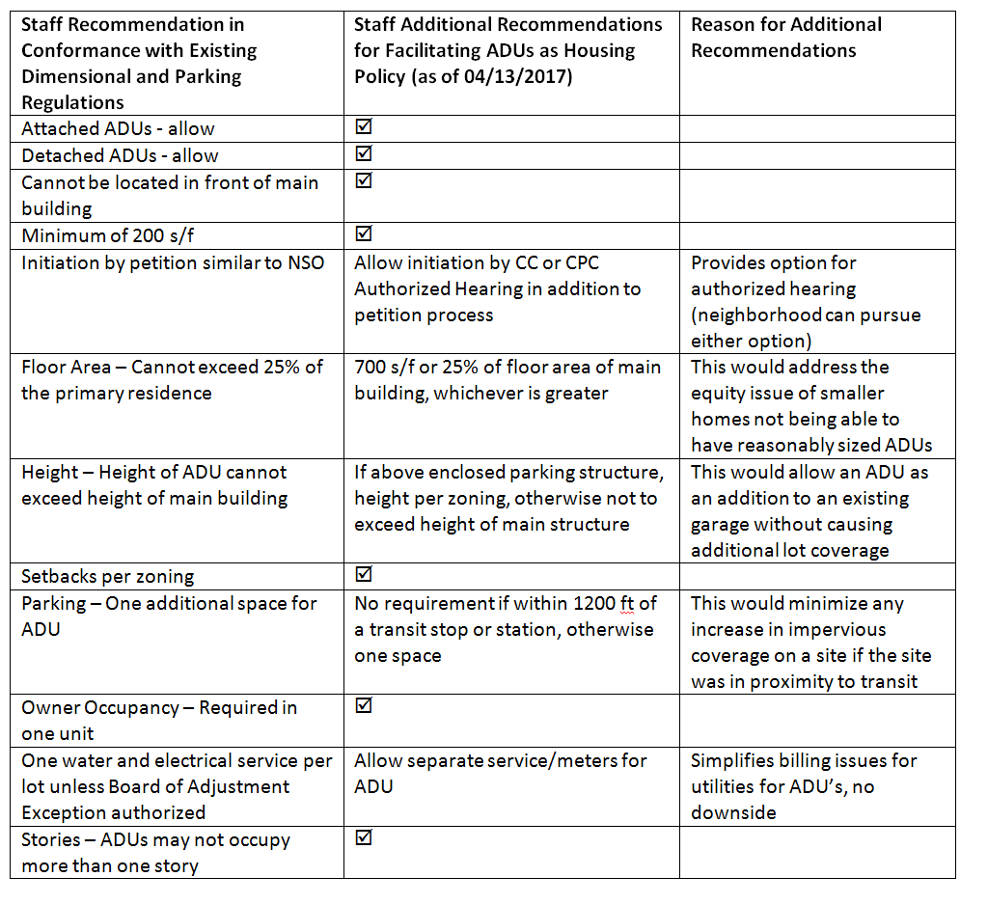

Zoning Ordinance Committee (ZOC) Meeting Minutes
April27, 2017

Motion that no change be made to the Dallas Development Code.

Motion: Murphy
2nd: Houston

Result: Passed: 7-0
For: Shidid, Murphy, Benedict, Hartmann, Brown, Gomez, and Houston
Against: None
Absent: None

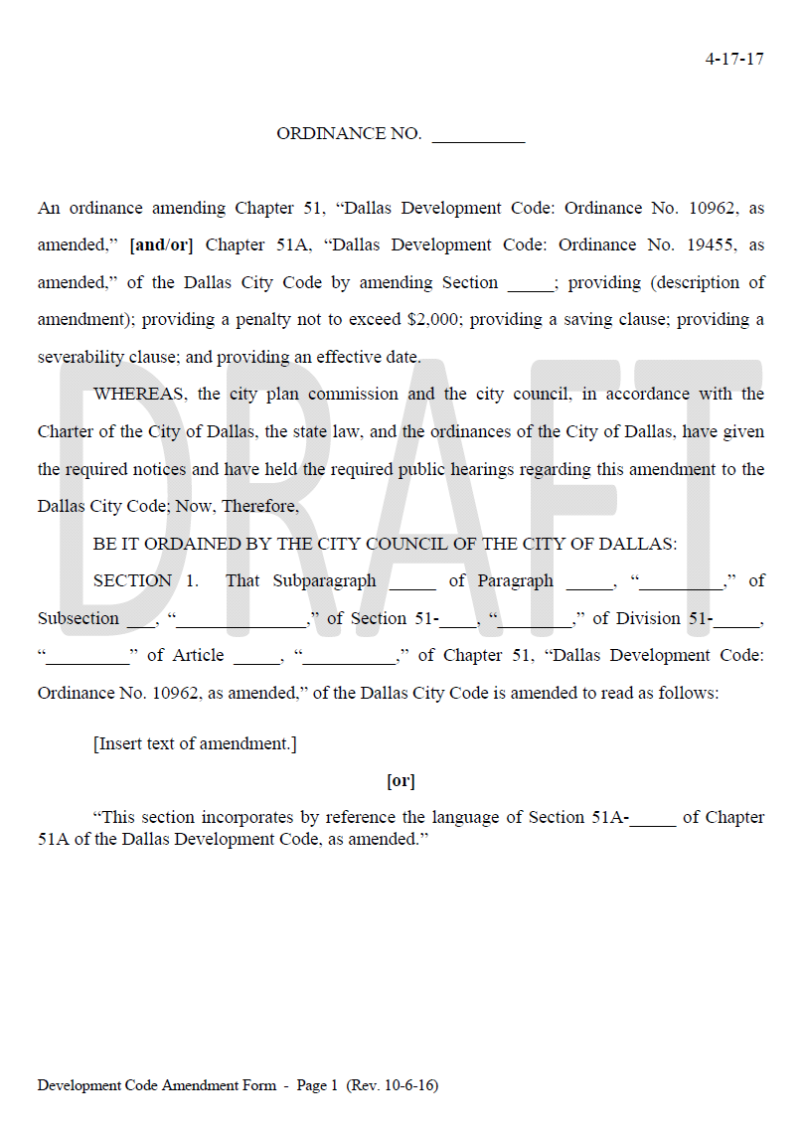
Board of Adjustment (BDA) special exception
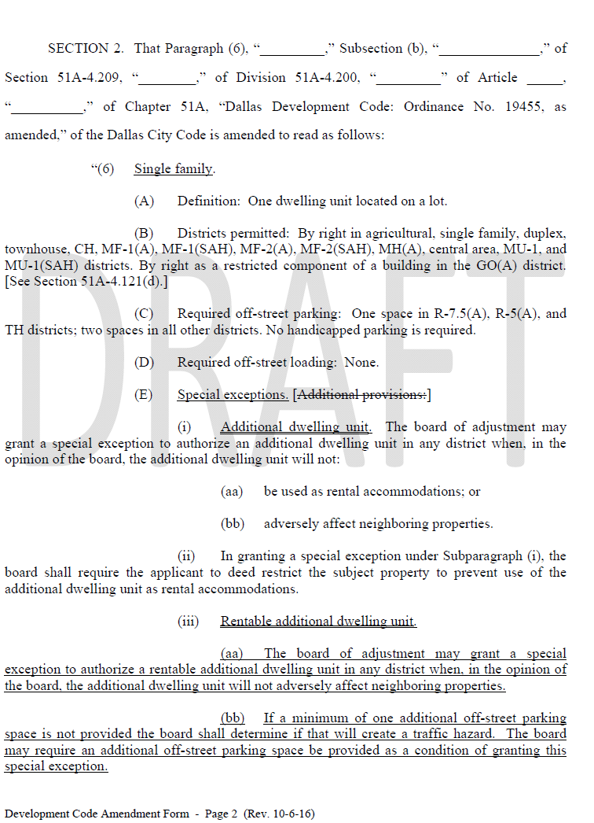

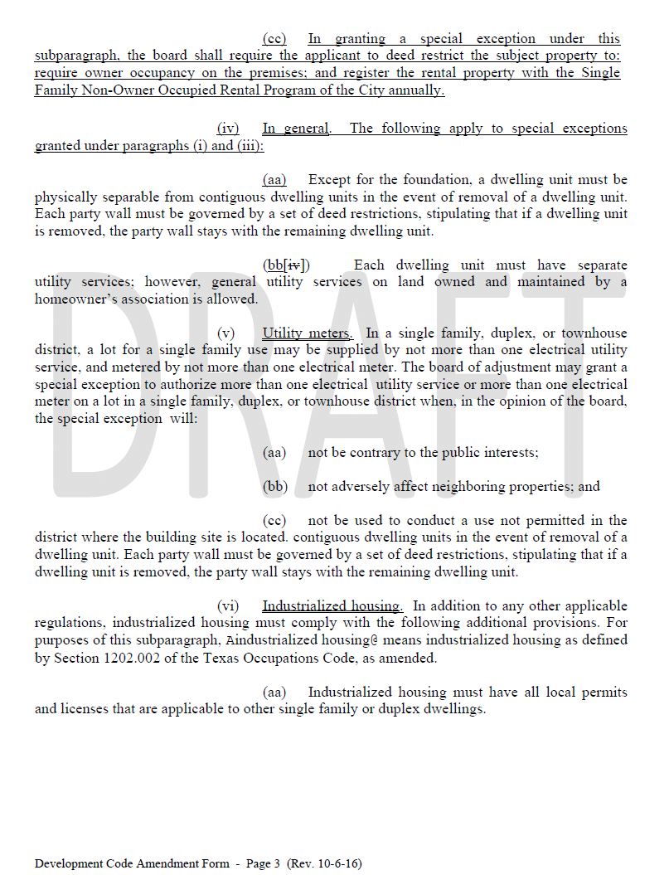

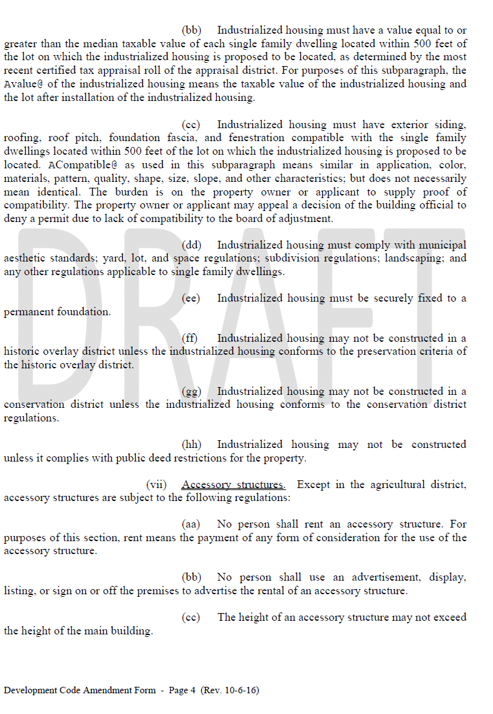

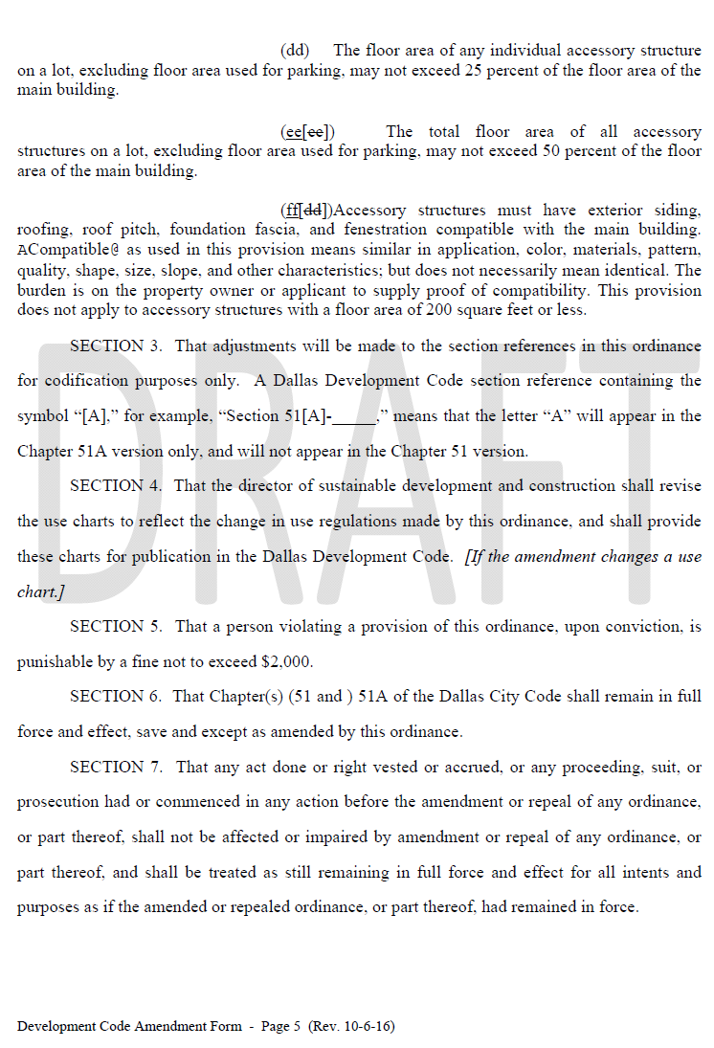

Accessory Dwelling Units (ADU) Overlay District


