ZONING ORDINANCE COMMITTEE THURSDAY, MAY 18, 2017

DALLAS DEVELOPMENT CODE AMENDMENT
FILE NO. DCA 156-009

Late Hours Overlay Planner: Diana Lowrance

REQUEST:

Consideration of amending the Dallas Development Code to create a new zoning overlay called, “Late Hours Overlay”.

BACKGROUND:

On August 8, 2016 the Quality of Life & Environment Committee was briefed and discussed the standards and regulations for late hour establishments in Planned Development District No. 842 (Lower Greenville) and directed staff to proceed to the Zoning Ordinance Advisory Committee. Refer to the Quality of Life & Environment Committee Meeting Record for the August 8, 2016 meeting (Appendix C).

On November 29, 2016, the Sustainable Development & Construction Department held a public meeting at the Erik Jonsson Central Library to get feedback from residents, property owners, and bar & restaurants owners regarding the issues related to parking for retail and personal service uses utilizing outdoor areas and a potential late hours overlay. Approximately 321 people attended, predominately from the hospitality industry.

On April 27, 2017, the Zoning Ordinance Advisory Committee was briefed on this item.

PRIOR ACTION AND UPATE:

The Committee asked staff what tools exist within City Code that address the concerns of adjacent residential neighborhoods, and for additional crime stats and information on SUPs in Planned Development District No. 842 (Lower Greenville).

Resources for Neighborhoods Adjacent to Commercial Districts

Resident-Parking-only Program

The Resident-parking-only (RPO) Program is intended to address the problems that arise when residential street are used for the parking of motor vehicles by persons using adjacent nonresidential parking generators, but who do not reside in the neighborhood. To report parking violations, a citizen must: 1) know the type of parking violation; 2) the location of the violation; 3) the license plate number of the vehicle in violation; 4) a description of the vehicle in violation, and 5) whether the violation is occurring on public or private property. Then the citizen must call City Services Dispatch at 3-1-1.

Noise Complaints

Chapter 30 of the Dallas City Code covers Noise. In the City, a person commits an offense if he makes or causes to be made any loud and disturbing noise or vibration in the city that is offensive to the ordinary sensibilities of the inhabitants of the city. Per 3-1-1, for the initial reporting of a noise complaint for a location, a citizen should call 9-1-1. However, to report noise complaints of a chronic or reoccurring nature, a citizen should call 3-1-1.

Public Intoxication and Trespassing

For complaints regarding public intoxication and trespassing, a citizen should call 9-1-1.

Specific Use Permits in PD 842

Since the adoption of Planned Development District 842 on January 26, 2011, twenty (20) Specific Use Permits (SUPs) have been applied for to allow Late-hours Establishments. Of the twenty, ten were for a late-hour establishment limited to a restaurant without drive-in or drive-through service; one was for a late-hour establishment limited to a commercial amusement (inside); six were for a late-hour establishment limited to a bar, lounge, or tavern; one was for a late-hour establishment limited to a commercial amusement (inside); two were for a late-hour establishment limited to a general merchandise or food store 3500 square feet or less and a motor vehicle fueling station. Additionally, of the twenty that were applied for, four were denied by City Council and one was denied by the City Plan Commission (with the applicant subsequently withdrawing their application). See Appendix A.

Crime Stats

Below is a table summarizing violent and non-violent crime in the reporting areas during the time period 2008 through 2016 from midnight to 6 a.m. On the following page is a map showing Reporting Areas 1161, 1164, 4510, and Planned Development District No. 842 (Lower Greenville). Additionally, see Appendix B for detailed crime data in the reporting areas for individual calendar years from 2008-2016. This information was provided by the Dallas Police Department’s Central Patrol Division.

Total Violent/Non-Violent Crime in Reporting Areas 1161, 1164, and 4510
from Midnight to 6 a.m. (by Calendar Year)
YEAR | 2008 | 2009 | 2010 | 2011 | 2012 | 2013 | 2014 | 2015 | 2016
CRIME TOTALS | 122 | 104 | 92 | 56 | 46 | 41 | 31 | 43 | 42

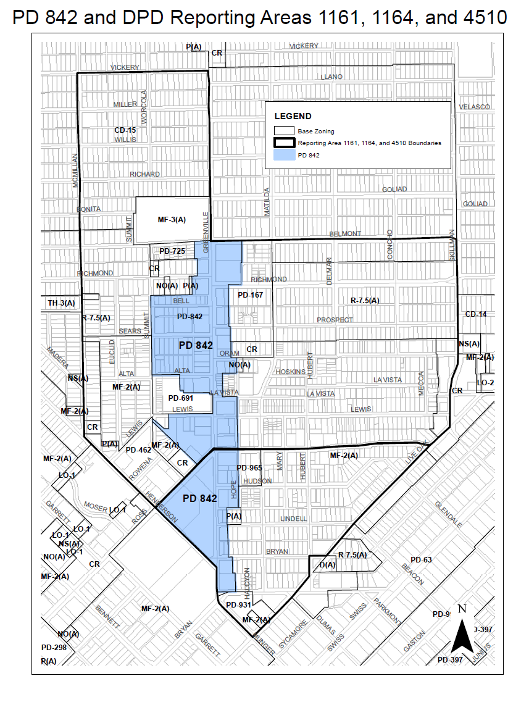

GENERAL INFO/STAFF ANALYSIS:

An overlay is a zoning tool which supplements the existing zoning district classification by establishing additional regulations or modifying existing regulations. Currently, the Dallas Development Code has seven types of overlays: (1) the Historic Overlay (which was established to preserve places of historical, cultural, or architectural importance and significance); (2) the Institutional Overlay (which was established to promote cultural, educational, and medical institutions, and enhance their benefit to the community while protecting adjacent property); (3) the Modified Delta Overlay (used in areas where continued use of the delta theory is not justified); (4) the Neighborhood Stabilization Overlay (used to preserve single family neighborhoods by imposing neighborhood-specific yard, lot, and space regulations that reflect the existing character of the neighborhood); (5) the Historic Building Demolition Delay Overlay (which was established to allow a review period for the demolition of buildings older than 50 years that met certain criteria); (6) the D and D-1 Liquor Control Overlay (which only applies to D and D-1 Liquor Control Overlay Districts that were enacted before June 11, 1987, and was established to control the sale or serving of alcoholic beverages); and (7) the Parking Management Overlay District (which was established to allow City Council to impose conditions to ensure the adequate provision and efficient management of parking). Parking Management Overlay Districts may only be established within WMU - Walkable Urban Mixed Use or WR - Walkable Urban Residential districts.

Currently, neither Chapter 51 nor Chapter 51A of the Dallas Development Code defines or has specific regulations for establishments that operate late into the early morning hours. Some examples of land uses that might be open for business between 12 a.m. and 6 a.m. are:

Chapter 51A Uses | Chapter 51 Uses
Alcoholic beverage establishments | Alcoholic beverage establishments
Commercial amusement (inside) | Inside Commercial Amusement
General merchandise or food stores (i.e., convenience stores, supermarkets, and drug stores) | Retail food store
 | Clothing store
 | Drug store
Personal service uses (i.e., tattoo parlors) | Personal service uses
Restaurants (with-out drive-in or drive-through service) | Restaurant without drive-in service
Restaurants (with drive-in or drive-through service) | Drive-in restaurant

Planned Development District No. 842, passed by City Council on January 26, 2011, regulates establishments that operate late into the early morning hours on Lower Greenville. The purpose of the PD was to ensure the compatibility of certain retail and personal service uses with adjacent residential neighborhoods. The PD defined a new use, “Late Hour Establishment,” as a retail and personal service use that operates between 12 a.m. (midnight) and 6 a.m.

ISSUES:

Different areas of the city have experienced impacts from establishments that operate late at night and into the early morning hours. Many of these establishments are in close proximity, if not adjacent to, residential neighborhoods. The concentration and proximity of these establishments may become a nuisance to nearby residential neighborhoods. Some issues potentially related to these uses are noise, crime, trash, and property damage, etc.

STAFF PROPOSAL:

The purpose of a Late Hours Overlay is to ensure the compatibility retail and personal service uses with adjacent residential neighborhoods.

General provisions.

(1) The City Plan Commission or City Council may initiate a “Late Hours Overlay District” following the procedure in Section 51A-4.701, “Zoning Amendments,” which is the authorization of a public hearing by the City Plan Commission or City Council.

(2) A late hours overlay may only be placed on an area that is zoned nonresidential or mixed use and developed primarily with retail and personal service uses. The area must be physically contiguous and be no less than a blockface in area. A Blockface means the linear distance of lots along one side of a street between the two nearest intersecting streets. If a street dead ends, the terminus of the dead end will be treated as an intersecting street.

Definitions and Interpretations.

(1) Unless otherwise stated, the definitions and interpretations in Chapter 51A or Chapter 51, as applicable, would apply to the overlay.

(2) However, in the overlay, a Late-Hours Establishment would mean a retail and personal service use in Chapter 51A and comparable uses in Chapter 51 that operates, offers services to the public, and/or has customers remaining in the establishment between 12 a.m. (midnight) and 6 a.m.

(3) All other requirements in the Dallas Development Code and City Code in addition to applicable state and federal regulations would apply to the district

Main Uses Permitted.

(1) The main uses permitted in any proposed overlay district would depend on the existing zoning, subject to the same rules and conditions applicable to those districts, as set forth in Chapter 51 or 51A of the Dallas Development Code, as applicable.

(2) However, the following use would be permitted only by SUP:

--Late-hours establishment

Additional provisions.

(1) Except for late-hour establishments operating under a valid specific use permit, approved subject to the factors listed herein, all services for the public must be stopped and all customers must be removed from the establishment between 12 a.m. (midnight) and 6 a.m.

Specific Use Permits in General.

SUPs provide a means for developing certain uses in a manner in which a specific use will be consistent with the character of the neighborhood. Each SUP application must be evaluated as to its probable effect on the adjacent property and the community welfare and may be approved or denied as the findings indicate appropriate. Dallas Development Code Chapter 51A, Section 51A-4.219 provides the general findings the City Plan Commission and City Council must consider when approving a Specific Use Permit (SUP).

Specifically, the City Council shall not grant an SUP for a use except upon a finding that the use will: (a) complement or be compatible with the surrounding uses and community facilities; (b) contribute to, enhance, or promote the welfare of the area of request and adjacent properties; (c) not be detrimental to the public health, safety, or general welfare; and (d) conform in all other respects to all applicable zoning regulations and standards. The regulations in this chapter have been established in accordance with a comprehensive plan for the purpose of promoting the health, safety, morals, and general welfare of the city.

Proposed Additional SUP Requirements for the Late Hours Overlay.

(1) Factors to be considered for a specific use permit for a Late-Hour Establishment. The City Plan Commission and City Council shall consider the following additional factors when making the findings required by Section 51A-4.219 (a)(3):

(i) The number of citations issued by police to patrons of the establishment;
(ii) The number of citations issued by police for noise ordinance violations by the establishment;
(iii) The number of arrests for public intoxication or disorderly conduct associated with the establishment;
(iv) The number of Texas Alcoholic Beverage Code violations of the establishment; and
(v) The number of violent crimes associated with the establishment, with emphasis on violent crimes originating inside the establishment.

Other Cities:
Reporting Area 4510
Reporting Area 4510
Reporting Area 4510

Fort Worth
- Some Planned Development Districts restrict hours of operation of certain uses.

San Antonio
- Massage businesses can only operate between 8:00 a.m. and 10:00 p.m.
- Billiard halls can only operate between 7:00 a.m. and 2:00 a.m.

Austin
- In the Neighborhood Commercial District, hours of operation for restaurants are limited to no later than 11:00 p.m.

San Jose, CA
    - Regulates late night use and activity by requiring Conditional Use Permits. Specifically,
      - No establishment other than office uses, in any commercial district shall be open between the hours of 12:00 midnight and 6:00 a.m. except pursuant to and in compliance with a conditional use permit
      - No outdoor activity, including loading, sweeping, landscaping or maintenance shall occur within one-hundred fifty feet of any residentially zoned property between the hours of 12:00 midnight and 6:00 a.m. except pursuant to and in compliance with a conditional use permit as provided in Chapter 20.100.
      - Regulates outdoor uses with 150 feet of residentially zoned property. Specifically
      - No use, which in whole or in part, consists of, includes, or involves any outdoor activity or sale or storage of goods, products, merchandise or food outdoors shall occur on any lands if any part of such lands or any part of the lot on which such buildings are located is situated within one hundred fifty feet of residentially zoned property situate within or outside the city except with a special use permit.

Source: http://www.dallaspolice.net/abouts/parkingEnforcement

