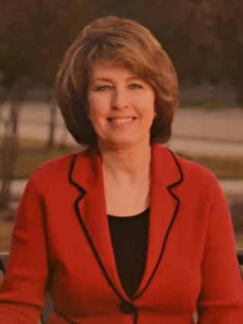
Councilwoman Sandy Greyson
District 12

BUDGET TOWN HALL MEETINGS

You are invited to attend any of the meetings listed below to discuss the proposed biennial budget prepared by City Manager T.C. Broadnax. District 12 projects for the 2017 Bond Program will also be presented.

Tuesday, August 15, 2017 at 7:00PM
Campbell Green Recreation Center
16600 Park Hill Drive,
Dallas TX 75248
214-670-6314

Thursday, August 17, 2017 at 7:00PM
Timberglen Recreation Center
3810 Timberglen Road,
Dallas TX 75287
214-670-0644

Tuesday, August 22, 2017 at 6:30PM
Renner Frankford Library
6400 Frankford Road,
Dallas TX 75252
214-670-6100

Dallas City Hall, 1500 Marilla Street, Room 5FN, Dallas TX 75201
Office Phone: 214-670-4067 Fax: 214-670-5650 Email: sandy.greyson@dallascityhall.com

