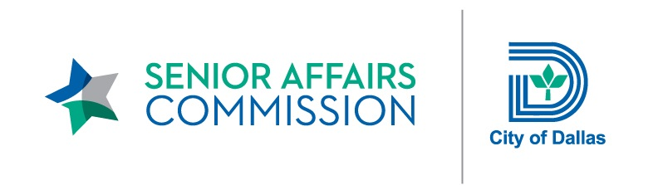

SENIOR AFFAIRS COMMISSION (SAC)
MONTHLY MEETING
REMOTE WEBEX MEETING
DIAL IN: 1-469-210-7159 United States Toll (Dallas)
DIAL IN: 1-408-418-9388 United States Toll
MEETING NUMBER (ACCESS CODE): 146 711 8557
MONDAY, SEPTEMBER 21, 2020
12:00 PM – 1:30 PM

Minutes

Meeting Date: Monday, September 21, 2020 Convened: 12:01 p.m. Adjourned: 1:30 p.m.

Committee Members Present: Committee Members Absent: City of Dallas Staff Present:
Jan Hart Black, Chair Bill Gart (Dist. 11) Ana Camacho, Manager Carmen Arana (Dist. 1) Jessica Galleshaw, Director VACANT (Dist. 2) Guests Myckycle Hart, Caseworker Verna G. Mitchell (Dist. 3) Sharla Myers, CEO Ali Hatefi, Assistant Director
VACANT (Dist. 4) Lynn Jenkinson, Caseworker Ja’net Huling (Dist. 5) Christopher Lutz, Manager
Marilyn Daniels (Dist. 6) Jacob McCarroll, Project Coordinator Cannon Flowers (Dist. 7) Jennifer Nicewander, Manager Debbie Austin (Dist. 8) Robert Perez, Director Beverly White (Dist. 9) Lupe Rios, Administrator Jeri Baker (Dist. 10) Efrain Trejo, Project Manager Zelene Lovitt (Dist. 12)
J. Peter Kline (Dist. 13) Sarah Wick (Dist. 14)

- Call to Order
Jan Hart Black, Chair, called the Senior Affairs Commission (SAC) monthly meeting to order at 12:01 p.m. and conducted
roll call to establish a quorum.

- No Public Comments

- Approval of August 24, 2020 Minutes
Zelene Lovitt made a motion to approve the August 2020 minutes. Peter Kline seconded the motion. The Commissioners
voted in favor of the motion.

- City of Dallas Sidewalk Plan, Department of Public Works
Ali Hatefi, P.E., CFM, Assistant Director, City of Dallas Department of Public Works, introduced Efrain Trejo, Project Manager, Department of Public Works, who presented an overview of the Sidewalk Master Plan. The City of Dallas identified a need to develop a comprehensive Sidewalk Master Plan to promote accessibility and comply with Title II of the Americans with Disabilities Act (ADA). Focus is on seniors over age 65 and people with disabilities. As part of the sidewalk selection, projects will include the following components: race, socioeconomic status, transportation access, age, people with disabilities, and social vulnerability index. Input from persons with disabilities will be employed to develop focused projects throughout the city. Citywide project ranking criteria will be utilized to prioritize target areas by generating a heat map and geographical data. A sidewalk committee will be formed in the next couple months and the final master plan approved by the end of February 2021. Funding available for sidewalks this fiscal year is 9.4 million dollars.
- City Operation and Services Update
Jessica Galleshaw, Office of Community Care (OCC) Director, provided an update on contract partners and changes in programs and services due to COVID-19:
- Changes are being made to the Home Improvement and Preservation Program (HIPP) including the launch date.

- Senior Dental Program services have resumed and operating at half capacity. Progress is continuing to be made on opening the South Dallas location.

- The Ombudsman Program is beginning to transition back to its typical operations. Ombudsman are now allowed to conduct nursing home visits.

- COVID-19 has dramatically affected the DART Program. Vehicles must be disinfected daily and riders have decreased.

Ana Camacho, OCC Senior Services Manager, presented an update on senior services. As of August 31, 2020, 1101 unduplicated clients have been served for referral and information, exceeding senior services’ fiscal year goal of 400 clients. Senior services has been receiving a lot of referrals for financial assistance. The Homeless Housing and Services Program (HHSP), funded by the state to prevent homelessness and to provide utility assistance to seniors 62 years of age and older, was extended until September 30, 2020. As of September 18, 2020, staff has served 44 out of 50 clients, the initial goal. Staff continues to strengthen partnerships by attending community meetings and by providing outreach and information to the community. The Senior Medical Transportation Program transitioned to the DART Rides Rider Assistance Program (RAP) in August 2020.

Program/Service Updates due to COVID-19, Community Council of Greater Dallas/Dallas Area Agency on Aging
Sharla Myers, Chief Executive Officer at Community Council of Greater Dallas, Dallas/Fort Worth Area provided an update on programs and services due to COVID-19. No home repair services were provided for two months due to COVID-19. These services have resumed with strict requirements. The majority of other services are conducted by phone. Medicare enrollment begins in October by phone and in-person by appointment only with face shields and masks. Temperatures are taken. Wellness programs have resumed virtually including online classes. The congregate meals programs ceased due to COVID-19. Meals are delivered to homes or transported to a drive by site. Number of meals per week have increased to seven due to a greater need for food.

District Updates
- Cannon Flowers recognized Daryl Quarles and the entire Park and Recreation Team for their effort in keeping seniors engaged at events during the pandemic.

- Jeri Baker reported that the construction of a bridge is about to begin in District 10, a goal of Age-Friendly communities.

- Debbie Austin stated that she is Chairperson for the Alzheimer’s Impact Movement (AIM) at the Alzheimer’s Association and plans to participate in the virtual walk on October 3, 2020.

- Upcoming Events
- October 26, 2020: Upcoming Senior Affairs Committee Meeting
- Subcommittees are making plans for their meetings.

- Adjournment
Ja’net Huling made a motion to adjourn the meeting at 1:30 p.m. Carmen Arana seconded the motion.

APPROVED BY:

________________________________
Jan Hart Black, Chair
Senior Affairs Commission (SAC)

