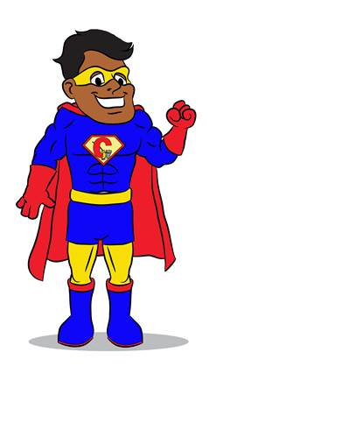
Captain Codey
Full Name: Captain Codey
Birthplace: Dallas, TX
Age: 25
Height: 6’0”
Super Abilities: Captain Codey has super human and extraordinary vision. This allows him to see neighborhood blight hundreds of miles away. His enhanced physical strength is far above that of any human being making him stronger than a Dallas Fire Truck. He also has super human speed that allows him to respond to citizen complaints faster than the normal Code Officer and he can clean the toughest neighborhoods in the blink of an eye. He can perform a heavy clean of a residence without the use of trucks or equipment. His super intelligence allows his brain to operate faster than any supercomputer. This allows him the ability to think fast to solve a citizen’s problems and concerns. Captain Codey is like a resource quarterback. When someone needs help within the Code Department or outside of Code Compliance, he knows who to call and when to call! He’s a facilitator amongst business leaders and the community. He specializes in premise violations and can bring people together --putting smiles on their faces.
He can also alter his personal gravity field to propel himself through the air at will causing him to fly on earth or travel at interstellar distances.
Code Debut: Pending
Favorites:
Color: Blizzard Blue
Food: Barbeque ribs & Chicken with a side of chocolate covered crickets
Songs: Why Can’t We Be Friends
Subject in school: History
Books: Green Eggs and Ham
Movies: Hero 6
Sayings/Quotes: Pending- Need more ideas
Dance Move: Dab
Likes: Eating cheesecake while meeting with City Officials
Dislikes: Getting popcorn kernels in his teeth, rulebreakers, mustard on his hotdog and pollution.
What do you do for fun? Captain Codey likes to visit the planet Mars and give casual reports to NASA each time he returns.
Other: Captain Codey joins forces with Police, Fire and other city departments to help educate and protect the Dallas community

