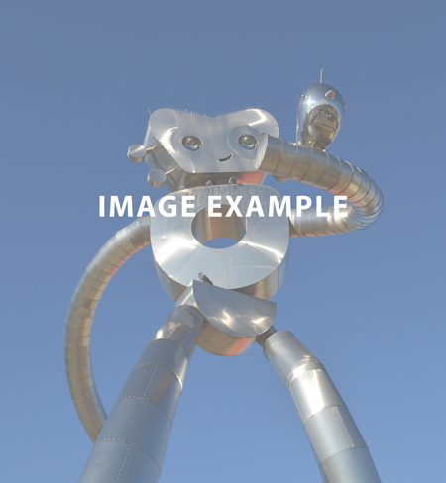

Event details  
August 21  
3:00 p.m. – 5:00 p.m.  
Location

Add more event information here.

For more information contact   
XXX.XXX.XXXX or XXXX@dallascityhall.com

*Click here to add a subtitle*

**Click here to add a Title**