Workday Icon Glossary

Common icons and their usage in Workday

Icon | Name | What it Means or How to Use
 | Home icon | Click this icon to return to the Home page from anywhere in the application.
 | My Profile icon | Displays links to the Home page, My Account, Favorite, etc.  Note: If you upload a photo for your profile, your photo will appear instead of this icon.
 | Inbox w/Badge | Displays your Inbox with badge count icon (gold circle) for new Inbox items.  Note: This icon displays “1” item in the Inbox.
 | Notifications | Used to review items you need to know about, but do NOT require any action
and | Expand/Collapse Arrows | Expands or collapses the Inbox view to/from full screen viewing mode.
 | Favorite | Marks an item as a favorite for sorting within the Inbox.
 | Search box | Allows you to quickly search for tasks, employees, organizations and reports.
Or Or | Related Actions | Use to initiate worker related actions. Can also be used to pop-out menu options.
OK  ok  Submit  Ok  Done  Ok  Or Or | Confirmation Actions | Use to confirm action and/ or progress to a following screen after completing activity on a view.
 | List View | Displays a list of values that are valid for a field.
 | Edit | Click to enter information in the field.
 | Required Field | Any field with a red asterisk is required to be completed.
or or  Add  Ok | Add | Various ways throughout the system to add an additional row or value.
or  Remove | Delete | Click to delete a row or value.
 | Export to Excel | Click to download the data results into Microsoft Excel.
 | Filter | Click to narrow the data results based on selected parameters.
 | View Printable Version (PDF) | Click to download a pdf version of a screen shot.
 | Settings | Used to access configuration/additional options on a specific screen.
 | More Options | Click to access additional options.
and | Move Rows | Change the order of data presented.
 | Calendar icon | Opens a calendar to assist you in selecting a date.
 | Process Complete | Process was successfully completed.
Manage Delegations | Delegation | Click to set up delegations so that other users can act on your behalf.
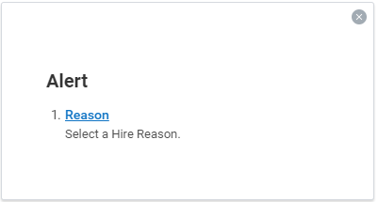 | Alert or Soft Warning | Yellow colored warning message notifies of potential problems on a page and provides advice of key issues that need attention. The alert DOES NOT stop further processing.
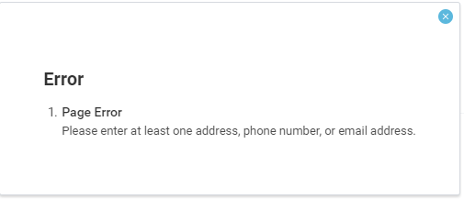 | Error Message | Red colored error messages provide advice on key issues that require attention. The alert DOES stop further processing.  Note: The accompanying text explaining the error appears next to the field containing the error if it is a field required by Workday. The text appears next to the error button if it is a CoD required field.
Or | Attachments | Click to upload documents or drag and drop.
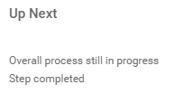 | Up Next | An automatic process is running in the background.  Note: Navigate to the Workday Inbox to check the status of the process.

Worklets
The following are common worklets used. Note: the worklet background colors might be different depending on both the order and number of worklets you have on your dashboard.

Worklet | Name | What it Means or How to Use
 | Inbox | Use to access tasks awaiting action.  Note: The number of actions awaiting action within the inbox will be displayed in a red circle on the profile icon.
 | Personal Information | Use to view and change your personal information such as name, email address, address, legal and preferred name and emergency contacts.
 | Benefits | Use to view and update benefit information.
 | Pay | Use to view and update withholding elections, direct deposit and view current and previous pay slips.
 | Time | Use to view or enter time worked or time off and view time off balances.
 | Absence | Use to request time off or leave of absence and view time off balances.
 | Favorites | Use to access the frequently-used Workday transactions that you have added to your favorites.
 | Talent and Performance | Use to provide employees the tools to measure their performance and unlock their full potential to grow their careers :
 | Career | Use for quick access to update specific parts of your talent profile as well as find jobs, refer candidates, or withdraw an application.
 | Performance | Use to review, add, and edit your performance goals.

