
City of Dallas

PLATTING
CITY OF DALLAS

GUIDELINES FOR SUBMISSION & PROCESSING

DEVELOPMENT SERVICES
ENGINEERING DIVISION
SUBDIVISION SECTION

December 2015

TABLE OF CONTENTS

Page | 2 |  | Table of Contents
Page | 3 |  | General Definitions
Page | 4 |  | Policy
Page | 5 |  | When Platting is Required
Page | 6 |  | Submitting a Preliminary Plat, Application Information
Page | 8 |  | Preliminary Plat Procedures
Page | 9 |  | Certificates of Correction, Correction Plats or Amending Plats
Page | 10 |  | Final Plat Procedures
Page | 12 |  | Final Plat Checklist
Page  Page | 13  14 |  | Subdivision Contact List  Preliminary Plat Checklist
Page | 15-16 |  | Plat Folding Diagrams
Page | 17 |  | Subdivision Fees

SUBDIVISION PLATS

A. GENERAL DEFINITIONS: PLAT

A plat is the graphic presentation of one (1) or more lots or tracts of land, or of a subdivision, resubdivision, combination or recombination of lots or tracts. It establishes a legal building site and is generally required before a building permit or certificate of occupancy can be issued.

A plat is not the same as a “tax plat” created by a deed for ownership and tax appraisal purposes, unless such a lot was created and remained in the same configuration (regardless of ownership) since September 11, 1929 or before annexation or consolidation.

Among other exceptions and conditions, an existing lot or parcel may be considered a building site if building permits for structures located on the property were issued before August 1, 1984. Any questions regarding whether a lot is a plat or has been previously platted as a subdivision or an addition plat should be directed to the Survey Records Vault, Room 314, Oak Cliff Municipal Center.

There are two steps to the platting process, Preliminary Plat approval and Final Plat approval, and the following types of plats:

MINOR PLAT: Plat which meets ALL of the following requirements:

1. An area of (5) five acres or less for residential zoning districts (R, D, TH); or

2. An area of (3) three acres or less for all other zoning districts; and

3. Requires no new public infrastructure such as streets, water, wastewater, paving, and drainage improvements.

ADMINISTRATIVE PLATS:

1. A minor plat involving four (4) or fewer lots fronting on an existing street, that is not located in a residential district, and that does not require the creation of any new street or the extension of municipal facilities is classified as an Administrative Plat.

2. Administrative Plats are approved by the Subdivision Administrator and do not require approval at a City Plan Commission hearing, thereby reducing the approval time.

3. The fees for an Administrative Plat are the same as those for a minor plat (see page 17).

4. Since an engineering analysis is needed to determine whether a plat will require the extension of municipal facilities (e.g. – water or sewer lines, storm drainage, etc.), it is strongly recommended that the applicant schedule a pre-submission meeting with the staff of the Engineering Division prior to submitting a formal application for an administrative plat to verify that it complies with the requirements for administrative approval. If review of the plat by the Engineering Division is delayed until after formal submission of the application, the amount of time required for approval may not be reduced as anticipated. Please contact the Subdivision Section to schedule a pre-submission meeting for administrative plats.

MAJOR PLAT: Plat other than a minor plat or a correction plat.

AMENDING PLATS

Amending Plat (Minor) A plat making minor changes to a previously recorded plat in accordance with state law provisions in which the amending plat purpose does not include the possibility of creating or eliminating a lot and which replaces the previous plat.

Amending Plat (Major) A plat making minor changes to a previously recorded plat in accordance with state law provisions in which the amending plat purpose includes the possibility of creating or eliminating a lot and which replaces the previous plat.

PHASED PLAT: A portion of an approved preliminary plat that receives final plat approval and is developed before or during the time the owner submits the final plat on the remainder of, or on another phase of, the area shown on the preliminary plat.

REPLAT: A plat changing a previously recorded plat that is not a minor or major amending plat and which replaces only the portion being replatted. A residential replat is a replat of property or a lot zoned during the preceding 5 years or deed restricted for no more than two residential units (e.g. – single family, duplex, and townhouse zoning districts).

REVISED PLAT: For fee purposes only, the addition of up to 10% of the area of a previously submitted preliminary plat. The application fee is ½ of the original fee. If more than 10% of the area is added, the revised plat is considered a new preliminary plat.

Minor Plats require a Preliminary Plat fee, but no Final Plat fee. Major Plats require separate fees for Preliminary Plat and Final Plat review, since site/grading plans, engineering plans, bonds, and contracts are frequently required in the platting process for Major Plats (e.g. – drawings and specifications for paving, stormwater drainage, water and wastewater utilities).

B. POLICY

1. It is the policy of the city of Dallas to subject the subdivision, platting and replatting of land to the control of the city pursuant to the city charter, state law, and all other rules, regulations, and policies the city may adopt.

2. To be platted, land must be of such character that it can be used safely for building purposes without danger to health or peril from fire, flood or other menace.

3. Land must not be platted until proper provision has been made for paving, drainage, water, wastewater, public utilities, fire protection, capital improvements, parks, recreational facilities, and rights-of-way for streets, transportation facilities, and improvements.

4. These policies supplement and are intended to facilitate the enforcement of the provisions and standards of the Dallas Development Code, state law, and all other rules, regulations, and policies which the city may adopt.

C. WHEN PLATTING IS REQUIRED

1. Creation of a building site: Platting is required to create a building site pursuant to Section 51A-4.601 of the Dallas Development Code.

2. Subdivision: Platting is required to divide a lot or tract into two or more parcels for purposes of development of the parcels. Although a conveyance of property may be accomplished through a metes and bounds description without the necessity of platting, the conveyance may not be recognized as a building site, nor for the purpose of determining development rights on the conveyed parcel.

3. Combination: Combine two or more lots or tracts into one lot.

4. Amend: Platting is required if property is to be developed in a manner inconsistent with an exiting plat.

5. Vacated and Abandoned Property: Platting is required to incorporate property that has been vacated or abandoned into a legal building site.

6. Corrections: Platting is required to correct an error on an approved and recorded plat.

7. Development plan for a planned development district: A preliminary plat shall be submitted with the development plan for a planned development district if the property is unplatted or is proposed to be a different lot pattern than what exists.

- Shared Access Development: Platting is required to establish a shared access development as provided in Section 51A-4.411 of the Development Code.

SUBMITTING A PRELIMINARY PLAT:

A. Pre-application: It is strongly recommended that the applicant consult with a Subdivision Planner prior to formal submission of a subdivision application. At this meeting, the Planner will advise the applicant of the subdivision regulations and policies relevant to the property to be platted.

B. Formal Application: The application shall be completed prior to being submitted to the City. Any incomplete submittal shall not be processed and all materials received shall be returned to the applicant. Plat applications identified during the review process by the Survey Section as having incorrect metes and bounds descriptions will be recommended for DENIAL to the Plan Commission. In addition, the property owner will be notified of the reason for the denial recommendation.

The following items must be submitted with the application (see also the checklist on page 14):

1. APPLICATION FORM: All applications are submitted to the Department of Development Services, Subdivision Section, Room 115, Oak Cliff Municipal Center, 320 E. Jefferson Blvd. The Subdivision staff reviews the application for completeness and schedules a Plan Commission hearing date within 30 days of the application acceptance date.

2. FOLDED COPIES: Thirty-five (35) folded copies of the proposed plat (for instructions for folding plats see pages 15 & 16).

3. PLAN COMMISSION COPIES: Submit thirty (30) 11 inch X 17 inch copies of the preliminary plat folded to 8 ½ X 11 inches (if the plat contains multiple pages, include only those pages which comprise the plat or lot layout, not the pages which include only the owners’ certificate, owners’ dedication, acknowledgements, etc.). These will be distributed to the City Plan Commission one week prior to the public hearing. Also submit one (1) copy at 11 inches X 17 inches of the face of the plat only (i.e. – excluding owners’ certificate, owners’ dedication, acknowledgements, etc.).

4. ZONING MAP: One 8 1/2” x 11” copy of the city’s zoning map with the proposed plat area outlined in red.

5. ORDINANCE: If the property to be subdivided is located wholly or partially within a Planned Development District, a Conservation District or a Historic District a copy of the ordinance for that district must be submitted with the preliminary plat.

6. FEE: A fee is required as reflected by the attached fee schedule (see page 17).

7. REPLATS: A certified copy of all previously recorded subdivision or addition plat containing the area being replatted, obtained from 320 E. Jefferson Blvd., Room 314; or the county courthouse.

C. DEADLINE: The deadline for submitting the plat application is generally Friday, 12:00 p.m., three weeks prior to the Thursday, City Plan Commission (CPC) hearing. Holidays may cause a change in established deadlines. For a detailed submission schedule, please refer to the official calendar available in the Subdivision Section, Room 115, Oak Cliff Municipal Center, 320 E. Jefferson Blvd.
PRELIMINARY PLAT PROCEDURES:

1. Routing: Plats are routed to other City Departments and Public Utility Companies within two (2) days of the plat being accepted by the Subdivision Section.

2. Comments: All City Departments and Public Utility Companies are required to return their comments to the Development Services Department, Subdivision Section within two (2) weeks of the CPC hearing.

3. Staff/Plat Review Committee: A meeting with the city staff to review the proposed plats is generally conducted on Friday morning, two weeks prior to the CPC hearing. At the staff meeting, the recommendation to the CPC is formulated. The meeting is normally attended by city staff only.

4. CPC Subdivision Review Committee: The committee meets on the morning of each Thursday’s CPC meeting on an as needed basis and reviews and makes recommendations to the City Plan Commission on subdivision plats, when the applicant is appealing any conditions of approval. This is a posted public meeting, and is open to the applicant and/or its representatives and any opponents.

5. City Plan Commission: The Commission meets every Thursday, except for the fifth Thursday of the month and holidays. There are fifteen Commission members, residents of the City of Dallas, appointed by the City Council. One function of the Commission is to review and take action on all subdivision plats, except Administrative Plats. Their action on plats is final. The meetings are open to the public and held in the Council Chambers of City Hall. Since the City Plan Commission serves as a “quasi-judicial” body in reviewing and approval subdivision plats, applicants may not contact any member of the Commission prior to the hearing.

- Commission Action: Within thirty (30) days of acceptance of the complete application, the Commission will approve, approve with conditions, or deny the subdivision plat. If the Plan Commission does not take action on the plat application within thirty days of submittal of the plat, the plat is automatically approved.

- Effective Period: An approved preliminary plat is effective for five years from the date of the Commission action if no progress has been made toward completion of the project in accordance with Texas Local Government Code Section 245.005. An approved minor plat, amending minor plat, or an administrative plat expires two years after the Commission action date or, in the case of an administrative plat, two years after the date of the subdivision administrator’s approval letter if no progress has been made toward completion of the project. Progress towards completion of a project includes any one of the following: submission of an application for a final plat, an application for a permit necessary to begin or continue towards completion, incurring of costs for developing the project, posting of fiscal security, or payment of utility connection fees or impact fees.

CERTIFICATES OF CORRECTION, CORRECTION PLATS OR AMENDING PLATS

- Purpose:

- Certificate of correction: A certificate making a minor plat amendment in the form of a document used to make a correction to a recorded plat in cases where a sketch is not needed for clarity. A letter from the City Surveyor indicating that the change qualifies as a correction plat is required at the time the application is submitted.

- Minor amending plat: A plat making minor changes to a previously approved plat in accordance with state law provisions in which the amending plats purpose does not include the possibility of creating or eliminating a lot. A minor amending plat is processed in a similar manner as a final plat.

- Major amending plat: A plat making minor changes to a previously approved plat in accordance with state law provisions in which the amending plats purpose includes the possibility of creating or eliminating a lot. A Major amending plat is processed the same as any other preliminary plat.

Correction plats or minor amending plats may be submitted and approved by the Subdivision Administrator for minor adjustments, errors or omissions in easements, lot or block numbers, lot line adjustments (for minor amending plats not in a residential district) or other minor features of recorded plats pursuant to Section 212.016 of the Texas Local Government Code.

B. Requirements: Depending on the County, the applicant shall submit twenty (20) copies of the certificate of correction or the correction plat. If the correction of a feature on the plat requires the approval of one or more city departments, the applicant will be required to secure these releases prior to the submission of the certificate or plat for final approval by the City Plan Commission.

Any certificates submitted on 8½ x 11 paper shall use 110# paper to allow the placement of the required City Plan Commission signature block stamp on the reverse side without affecting the front side of the certificate.

C. Fee: A fee is required as reflected by the attached fee schedule (see page 17).

D. Filing: Certificates of correction and correction plats are filed in accordance with the procedures indicated for final plats.

FINAL PLAT PROCEDURES:

A. Deed: A copy of the recorded deed must be included with the final plat submittal. Failure of the deed and proposed plat map to match will delay release of the final plat by the Survey Section.

B. Requirements: Final plats will not be accepted until all departments requiring releases have provided written releases to the Subdivision Section of the Development Services Department. If all departments have released the plat, the following items are required in order to submit the final plat:

C. County Requirements: It is recommended that the applicant or surveyor contact the appropriate County Clerk for the correct items necessary to file the plat. The latest requirements of the various counties are:

1. Dallas County:

a. Twenty (20) signed and folded black line prints (see Pages 15-16) of which at least two prints shall have original signatures (this is a state law requirement).

b. A copy of the tax certificate for the property to verify that County and City taxes have been paid and are up-to-date.

2. Collin County:

a. Twenty (20) signed and folded black line prints of which at least two (2) prints shall have original signatures.

b. One (1) 24" X 36" white or clear Mylar with original signatures (please allow space for additional stamps on signature page).

c. A copy of the tax certificate for the property to verify that County and City taxes have been paid and are up-to-date.

3. Denton County:

a. Twenty (20) signed and folded black line prints of which at least two (2) prints shall have original signatures.

b. Three (3) 18" x 24" blue line prints all with original signatures (please allow space for additional stamps on signature page)

c. One (1) 18" x 24" black line mylar with original signatures.

d. One (1) 8½" X 11" clear transparency (reduction of plat).

e. A copy of the tax certificate for the property to verify that County and City taxes have been paid and are up-to-date.

D. Fee: The final fee will be collected at the time of submission of the prefinal or final plat. The fee will be determined by the attached fee schedule (Page 17). Each county has filing fees and it is the responsibility of the applicant to contact the appropriate county clerk for the applicable fees.

E. All of the final plats submitted for recording are to be retained by the county and the city. If the applicant and/or its representative wishes to retain a copy of the recorded plat, additional copies of the plat shall be submitted along with the required number of plats.

F. Deadline: The normal deadline for submitting the above required items is Tuesday, 3:00 pm., the week of the City Plan Commission hearing, although this is not a guarantee that the final plat will be signed. The final plat will be routed to the Survey Section to determine if the plat meets the requirements for recording. The final plat will be presented for the chairman’s signature at the first available Commission hearing.

G. Procedure: The chairman and secretary of the Commission sign the final plat. All signed plats are then returned to the Subdivision Section and prepared for filing with the appropriate county. It is the responsibility of the owner/applicant or its representative to pick up the signed final plats from the Subdivision Section office, take them to the appropriate county, obtain the tax certificates, file the plats with the county clerk, and return eighteen (18) stamped copies, of which one must be an original signature, to the Subdivision Section.

Failure to return the recorded plats to the Subdivision Section may result in holds being placed on your Building Permit(s)/Certificate(s) of Occupancy or revocation of permit(s) and/or certificate(s) of occupancy.

FINAL PLAT CHECKLIST

Omission of any of the following items from a final plat may be cause for rejection of the application.

Subdivision Addition name.

Subdivision Application File Number.

Names and addresses of developer, surveyor and owners of record, date of preparation and revision.

Vicinity map, north arrow and scale of map.

Survey and Abstract Numbers.

Owner's certificate with signature of all owners, owners' notary, surveyor's stamp or seal and signature of surveyor and surveyor notary.

Boundary of project area drawn with bold line (other boundaries shall be of thinner lines or subdued).

Each lot and block numbered as assigned by the GIS Section of the Department of Development Services.

Exact dimensions and bearings of all boundaries and lot lines.

Exact location, dimensions, name and description of all existing and proposed streets, alleys, easements or public right-of-way within the subdivision, intersecting,
or contiguous with its boundary.

All corrections, conditions or additions as required by the Commission or reviewing departments.

Provide a copy of the CADD file of the final plat on a “CD” in a format compatible with “MicroStation,” with the final plat, regardless of the type of plat. The CD must contain an affixed label that contains the “S” Number, Addition Name, and the Surveyors telephone number.

□ A copy of the recorded deed and a copy of the title policy; or if no title insurance, a copy of the most recent tax certificate.

SUBDIVISION CONTACT LIST

Development Services 320 E. Jefferson Blvd.
Engineering Division – Room 200 Hamid Fard, Sr. Engineer –214-948-4223
Drainage, Grading & Stormwater:
Lupe Lomas, Office Assistant – 214-948-4205

Water & Wastewater: Dorian Franck – 214-948-4602
Gordon Robinson – 214-948-4633

Survey Group: Danny Fugate – 214-948-4496
John Loftis – 214-948-4496
John Stepp – 214-948-4497
Subdivision Section – Room 115
Subdivision Administrator: Paul Nelson - 214-948-4452
Senior Planner: Sharon Hurd – 214-948-4531
Development Coordinator: La Shawn Green – 214-948-4335
Development Coordinator: Ellen Wallace - 214-948-4454
Coordinator: (Early Release): Mohammad Bordbar – 214-948-4622
Office Assistant Fay Lewis – 214-948-4334

Lot and Block Numbers: Bob Self - 214-948-4135

Arborists – Room 105:
Chief Arborist: Phillip Erwin -- 214-948-4117
Arborist: Tina Standeford - 214-948-4484
Arborist: Clay Walker - 214-948-4471
Arborist: David Wong - 214-948-4172

SDC Real Estate – Room 203
Chief Real Estate Specialist: Donna Smithson-Kirwin – 214-948-4112
Acquisitions: Kathy Green – 214-948-4122
Abandonments: Garrett Murphree – 214-948-4159

City Hall: 1500 Marilla Street
Street Lighting, Rm. L1/B/N: Brad Moss – 214-670-1229
Transportation Planning, Rm. L1/B/N: Keith Manoy – 214-670-4038

Fire Department
Communication, Rm. L1/C/S: 214-670-3352
Park & Recreation
Planning & Research, Rm. 6/F/S: Jason Ney – 214-670-4103

Department of Public Works & Transportation, 320 E. Jefferson Blvd.
Survey Records Vault, Room 314 214-948-4149
Chief City Surveyor: Scott Holt 214-948-4113

DART (Dallas Area Rapid Transit), 1401 N. Pacific; Steven Biba – 214-749-2570

United States Postal Service: Scott Wright
The AMS, Growth Coordinator
951 W Bethel Rd
Coppell, TX 75099-9321
Telephone:972-393-6433

PRELIMINARY PLAT CHECKLIST
Omission of any of the following items from a preliminary plat may be cause for rejection of the application

 | All required fees
 | 8 ½” X 11” ZONING MAP WITH AREA OF PLAT OUTLINED IN RED.
 | copy of THE RECORDED deed & A copy of title policy (IF NO TITLE INSURANCE, A COPY OF THE MOST RECENT tax certificate) .
 | Proposed plat legibly drawn ON A Sheet of paper 24 inches by 30 or 36 inches in size.
 | Scale of 1" = 40' or the largest practical scale approved by the director of Development SERVICES
 | Boundaries of plat in SOLID bold lines, LOT LINES (INCLUDING ADJOINING LOT LINES) & BLOCK LINES in thin lines. DASH OLD LOT LINES & GHOST OLD LOT NUMBERS, TRACT LINES & NUMBERS.
 | SURROUNDING PLATTED LOTS AND/OR OWNERSHIP LINES FOR UNPLATTED TRACTS WITHIN 150 FEET SHOWING ADDITION NAMES, PROPERTY OWNER NAMES(S), LOT & BLOCK NUMBERS, VOLUME & PAGE & SOURCE OF RECORD.
 | Vicinity map showing all thoroughfares and existing streets within the two intersecting major thoroughfares nearest of the boundary of the plat.
 | Proposed name of the subdivision.
 | Total acreage of proposed plat.
 | THE PURPOSE OF THE PLAT INCLUDED AS A NOTE ON THE PLAT.
 | OWNERS & SURVEYORS ACKNOWLEDGMENT & DEDICATION forms, AND signature BLOCK (UNSIGNED); AND preliminary plat stamp “preliminary, This document shall not be recorded for any purpose”.
 | LAYOUT AND LOTS NUMBERED AND AREA OF EACH LOT NOTED; or TABLE IDENTIFYING EACH LOT AND THE SQUARE FEET OR ACREAGE OF EACH LOT.
 | EXISTING TRACT OR lot AND BLOCK numbers listed in title block WITH A DESCRIPTION OF THE PURPOSE OF THE PLAT OR SUBDIVISION.
 | NAME AND ADDRESS OF EACH OWNER, DEVELOPER, ENGINEER AND/OR SURVEYOR. NOTE: THE ENGINEER AND/OR SURVEYOR OF THE PLAT CAN NOT BE THE APPLICANT UNLESS THEY ARE ALSO THE OWNER.
 | TRUE NORTH ARROW AND LEGEND INDICATING SYMBOLS USED ON THE PLAT.
 | LAYOUT, NAME AND DIMENSION OF ADJOINING OR PROPOSED STREETS AND ALLEYS (TOTAL WIDTH AND WIDTH FROM CENTERLINE) AND all PROPOSED STREET NAMES.
 | Location and identification of any structure or object within the boundaries of the property to be platted; location and identification of any significant topographic features located on the property or within 150 feet of the property to be platted. Note: any of these items which are to be removed or altered must be so identified on the plat. IF NO STRUCTURES ON THE SITE, PLEASE indicate via a NOTE that no structures exist.
 | LOCATION and PURPOSE OF PROPOSED EASEMENTS AND COMMON AREAS.
 | appropriate language of dedication and acknowledgment forms.
 | FOR ALL REPLATS, A CERTIFIED copy of the most recent recorded ADDITION OR SUBDIVISION plat from the survey VAULT in room 314, 320 e. jefferson blvd. OR THE COUNTY OF RECORD
 | Location, purpose, and grantee of existing easements, with the volume and page of the county record(s) where the instrument may be found.
 | LAYOUT OF PLATTED LOTS, UNPLATTED TRACTS, STREETS, STORM DRAINAGE, WATER AND WASTEWATER FACILITIES, PUBLIC RIGHT-OF-WAY, OTHER AREAS OFFERED FOR DEDICATION TO PUBLIC USE, AND PERTINENT FEATURES WITHIN (150) FEET OF THE PLAT.
 | (5) FOOT OR LESS CONTOUR INTERVALS. NOTE: THE DIRECTOR OF the Development Services Department MAY REQUIRE CONTOUR INTERVAL LESSTHAN 5 FEET WHERE THE SLOPE OF THE LAND IS LESS THAN 1 TO 100.
 | Tree Survey showing the location, caliper and names (both common and scientific) of all trees near proposed construction (trees in close proximity that all have a caliper of less than eight inches maY be designated as a "Group of trees" with only the number noted).
 | Metes and Bounds description AND LOT & BLOCK NUMBER of the property included in the plat (incorrect description may result in denial of the application).
 | Copy of any Specific Use Permit, zoning change ordinance, board of adjustment decision, or planned development district ordinance regulating the property; ALSO A COPY OF any deed restrictions on the property IN which the City of Dallas is a party.
 | COPY OF Escarpment permit if the proposed plat lies within the escarpment area or geologically similar area.
 | (15) BLUE OR BLACK LINE PRINTS folded in accordance with attached diagram.
 | (2) 11” X 17” BLACK LINE PRINTS FOLDED TO 81/2” x 11” IN ACCORDANCE WITH attached diagram (EXCLUDING PAGES WITH ONLY OWNERS’ CERTIFICATE, DEDICATION, & ACKNOWLEDGEMENTS).
 | (1) 11”x17” BLACK LINE PRINT OF THE FACE OF THE PLAT (EXCLUDING OWNERS’ CERTIFICATE, OWNERS’ DEDICATION, ETC.).
 | (1) CD CONTAINING THE PLAT IN A MICROSTATION COMPATIBLE FORMAT AS SPECIFIED BY THE cITY SURVEYOR.
 | IF THE PLAT INVOLVES ONLY PART OF A PLATTED LOT & THERE IS A STRUCTURE ON THE REMAINDER PORTION OF THE LOT, PROVIDE A COPY OF THE BUILDING PERMIT(S) FOR THE STRUCTURE ON THE REMAINDER LOT.
HOW TO FOLD 24” X 36” PLATS
PLACE PLAT PRINTED SIDE UP READING LEFT TO RIGHT,
THEN FOLD AS FOLLOWS:
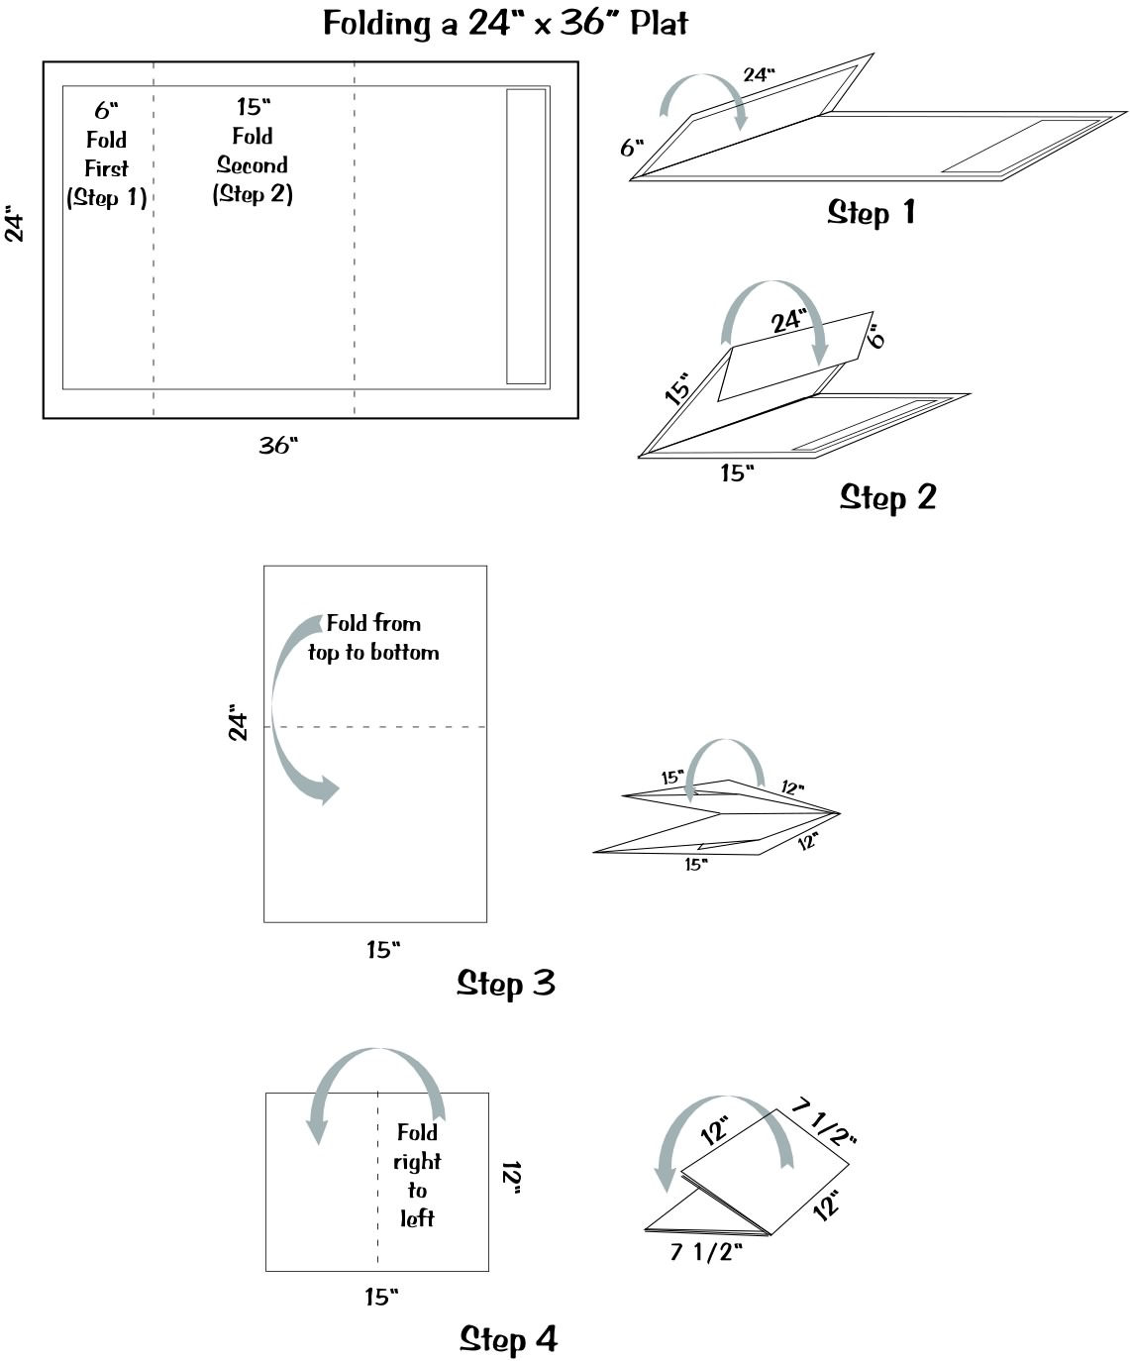

FINISHED SIZE SHALL BE APPROXIMATELY 7.5” X 12” AND FOLDED SO OUTSIDE HOW

FINISHED SIZE SHALL BE APPROXIMATELY 7.5” X 12” AND FOLDED SO OUTSIDE PORTIONS ARE BLANK

HOW TO FOLD 11” X 17” PLATS

PLACE PLAT PRINTED SIDE UP READING LEFT TO RIGHT,
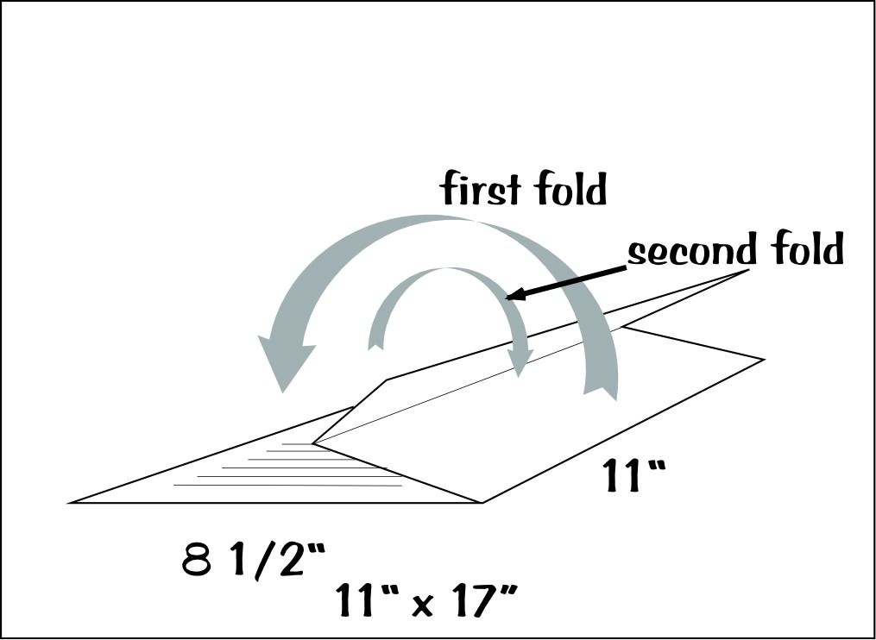
THEN FOLD AS FOLLOWS:

Finished size shall be approximately 8.5” X 11”.
SUBDIVISION FEES

THIS FEE SCHEDULE IS SUBJECT TO CHANGE BY ACTION OF THE DALLAS CITY COUNCIL.

Major Plat – more than 5 acres for single-family, duplex & townhouse districts or over 3 acres for all other zoning districts, and/or requiring public infrastructure, and/or existing improvements to remain do not meet all setbacks:

Preliminary plat, major amending plat, or final plat containing 20 lots or fewer:

- $1,548 plus $17 per lot if no lot exceeds 3.0 acres for a preliminary plat.
- $1,548 plus $17 per lot if no lot exceeds 3.0 acres for a final plat.
c. $1,548 plus $70 per acre if any lot exceeds 3.0 acres for the preliminary plat.
d. $1,548 plus $70 per acre if any lot exceeds 3.0 acres for the final plat.

Preliminary plat, major amending plat, or final plat containing more than 20 lots:

- $2,193 plus $17 for each lot if no lot exceeds 3.0 acres for a preliminary plat.
b. $2,193 plus $17 for each lot for a final plat.
c. $2,193 plus $70 per acre for each acre if any lot exceeds 3.0 acres for a preliminary plat.
d. $2,193 plus $70 per acre for each acre if any lot exceeds 3.0 acres for a final plat.

Minor plat submitted as a final plat for an area which does not exceed 5.0 acres for single-family, duplex & townhouse districts; or 3.0 acres for all other zoning districts:

$2,664 plus $26 for each lot that does not exceed 5.0 acres in residential districts, or 3.0 acres in nonresidential districts.

Minor Amending Plat (Certificate of Correction), Vacation of Plat, removal or relocation of building lines: $323

Revised Plat – a submission of a preliminary plat, amending plat, or final plat that has not been recorded and in which the area of the plat has been increased up to 10%:

One half of the fee schedule in effect at the time the revision is submitted.

The maximum charge is $19,350 for a preliminary plat and $19,350 for a final plat.

Refund of filing fee:
After the posting deadline no refund will be issued. If the application is withdrawn prior to the application being posted for hearing (Friday afternoon of the week prior to the hearing, or the last work day prior to Friday (if Friday is a holiday) 35 per cent of the filing fee will be refunded to the applicant.

