LODGING USES
In Planned Development Districts

PD 316. Jefferson Area Special Purpose District
BOUTIQUE HOTEL means a lodging facility with 30 or fewer guest rooms that are rented to occupants on a daily basis for not more than 14 consecutive days; provides food that is prepared on-site; and more than 50 percent of the guest rooms are internal-entry.
Parking - Boutique hotel. Two off-street parking spaces, and one off-street parking space for each guest room or suite is required. No required off street loading.

BED AND BREAKFAST means a lodging use that has no more than five guest rooms; provides accommodations for periods not to exceed five nights; serves no meals other than breakfast; and is a member of, or certified by, a recognized bed and breakfast association such as the National Bed and Breakfast Association (NBBA) or Historic and Hospitality Accommodation of Texas.
Lodging uses.
-- Bed and breakfast.
-- Boutique hotel.
-- Hotel or motel. [Subarea 2 only; minimum of four stories required.]

Parking - Bed and breakfast. Two off-street parking spaces, and one off-street parking space for each guest room or suite is required. No required off street loading.

PD 468. Oak Cliff Gateway Special Purpose District
BOUTIQUE HOTEL means a lodging facility with 30 or fewer guest
rooms that are rented to occupants on a daily basis for not more than 14 consecutive days;
provides food that is prepared onsite; and more than 50 percent of the guest rooms are internal entry.

Boutique hotel. One space is required for each unit. Off-street loading must be provided as follows:

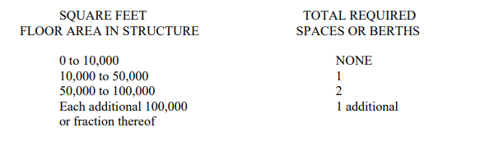

Lodging uses.
-- Extended stay hotel or motel [SUP. Limited to internal entry guest
rooms only, including interior courtyard-entry guest rooms.]
-- Hotel or motel. [RAR]
-- Lodging or boarding house. [SUP]

Parking as per 51A-4.200

PD 269. Deep Ellum
BED AND BREAKFAST means a lodging use that has no more than five guest rooms; provides accommodations for periods not to exceed five nights; serves no meals other than breakfast; and is a member of, or certified by, a recognized bed and breakfast association such as the National Bed and Breakfast Association (NBBA) or Historic and Hospitality Accommodation of Texas.
Lodging uses.
-- Extended stay hotel or motel. [SUP]
-- Hotel or motel. [SUP if 60 or fewer guest rooms.]

Parking as per 51A-4.200

PD 1002. East Side Special Purpose District
BED AND BREAKFAST means a lodging use that provides over-night accommodations; serves no meals other than breakfast; and is a member of, or certified by, a recognized bed and breakfast association such as the National Bed and Breakfast Association (NBBA) or Historic and Hospitality Accommodation of Texas.

Bed and breakfast. One space per guest room is required. No off-street loading required.

Lodging uses.
-- Bed and breakfast. [Limited to no more than five guest rooms and limited to providing accommodations for no more than five consecutive nights.]
-- Hotel or motel.

Parking as per 51A-4.200

