Turn in applications and all corresponding documents to:  Dept of Transportation-Parking Management & Enforcement  320 E. Jefferson Blvd, Suite 212  Dallas, TX 75203  Or via email: TRNParkingServices@dallascityhall.com | License Material Received By
 | Signature |  | Date

LICENSE INFORMATION
Chapter 32 of the City Code requires applications to be approved by City of Dallas Parking Management & Enforcement. Once an application is submitted you will be contacted when the process is complete concerning the application status or to pick up your permit. During any event, all approved locations may be subject to restrictions and/or complete suspension if parking on this property is deemed a public safety hazard by the City of Dallas Fire Rescue Department.
APPLICANT INFORMATION
Applicant Name:
 | First name |  |  |  | Last name
Applicant Home/
Mailing Address:
 | Street Address |  |  |  |  |  | City State Zip
Daytime Phone #: |  |  | Alternate Phone #:
Email Address:
TX Driver’s #: |  |  | License Plate #:
Name of Property Owner:
 | First name |  |  |  | Last name
Are you the  property owner? | Yes No | Are you authorized to  park vehicles at this location? |  |  |  |  | Yes No
Are you obtaining this  permit as a business? | Yes No | Business Name:
Business Address:
 | Street Address |  |  |  |  |  | City State Zip

SITE INFORMATION This application, if approved, authorizes the above party to park vehicles on the property located at the following address.
Site Address:
 |  |  | Street Address |  |  |  |  | City State Zip
Is this a vacant lot? |  |  | Yes No |  | Is the site owned by the City? |  |  | Yes No
APPLICANT AGREEMENT
I, the applicant, have read and fully understand the information and procedures above. I declare that all information provided is true and accurate to the best of my knowledge. Furthermore, I understand that giving false information will result in this application being denied.
Applicant Signature Date
*** FOR INTERNAL USE ONLY***
Preauthorization Status |  | Pre-Approved ON HOLD: CoD Real Estate Lease Required Released: CoD License Obtained
Reviewed by City of Dallas Parking Management
Approved On Hold Denied:
Parking Services (Print) Signature Date Authorized
Payment Type | Cash |  |  | Check |  | Money Order |  | Credit Card
Payment Center Cashier: |  |  |  |  |  | Fee Amount: |  | Date Paid:

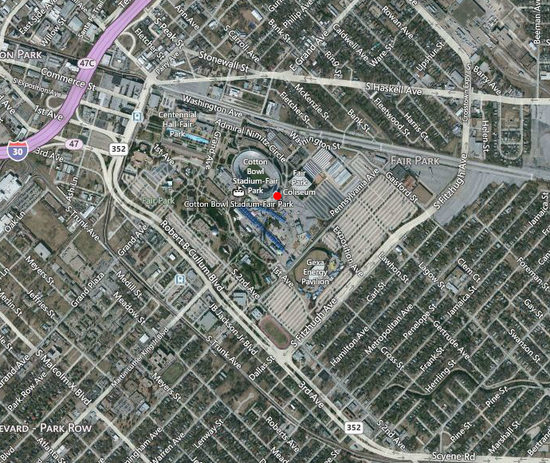
.
Fair Park Parking License Area/Boundaries
Boundaries of Fair Park Parking Area are determined by City ordinance, Sec 32-21. These boundaries were approved August 28, 2013.

- BEGINNING at the intersection of the southeast right-of-way line of R. L. Thornton Frwy (I-30) with Peak St;
- THENCE southeastward along Peak St to Stonewall St;
- THENCE eastward along Stonewall St to McKenzie St;
- THENCE southeastward along McKenzie St to Herndon St;
- THENCE southward along Herndon St to the southwest line of the DART right-of-way;
- THENCE eastward along the southwest line of the DART right-of-way to Metropolitan St;
- THENCE southwestward along Metropolitan St to the northeast line of the DART right-of-way;
- THENCE northwestward along the northeast line of the DART right-of-way to Martin Luther King, Jr. Blvd;
- THENCE southwestward along Martin Luther King, Jr. Blvd to Malcolm X Blvd;
- THENCE northwestward along Malcolm X Boulevard to Grand Ave;
- THENCE northeastward along Grand Ave to the northeast line of the DART right-of way;
- THENCE northwestward along the northeast line of the DART right-of-way to the southeast line of I-30 Frwy;
- THENCE northeastward along I-30 Frwy to the point of beginning.
1
2
3
4
6
7
8
9
10
11
12
13
5

