Meet the City of Dallas staff working in your neighborhood. We will be your first point of contact.
Para preguntas o inquietudes, llame al Inspector.
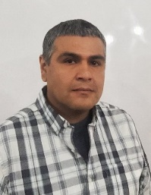Inspector
My name is Christian Maldonado I am your direct contact for any questions or issues you might have during the construction process. Contact info 945-201-0544 or at Christian.maldonado@dallas.gov 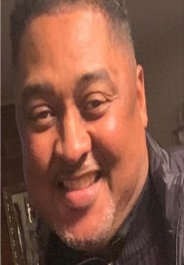 Supervisor
My name is Michael Thomas I am the Supervisor in the field for the contractor that is doing work on your street. Contact info 469-866-2286 or at Michael.thomas @dallas.gov
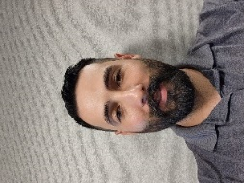 Manager
My name is Jeremy Tamez I am the Manager for this contractor, I oversee all construction aspects related to all work done on your street, Contact info 945-269-8448 or at Jeremy.tamez@dallas.gov

For any further compliments or complaints please reach out to christopher.lutz@dallas.gov
Para más elogios o quejas, comuníquese con christopher.lutz@dallas.gov
(Program Administrator)

