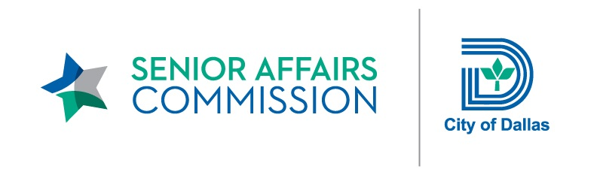

SENIOR AFFAIRS COMMISSION

Monday, February 26, 2018 – 12:00 p.m.

Dallas City Hall – 5ES Conference Room

AGENDA

- Call to Order – Sharyn Fein, Chair
City of Dallas Senior Affairs Commission

- Approval of January 2018 Minutes

- Chhunny Chhean, City Attorney’s Office
Code of Conduct

- Chair Report – Sharyn Fein, Chair
- Listening Sessions
- Vote on Mission, Vision, and Goals for 2018
- Discussion about Committee Goals for 2018

- Senior Affairs Commission Committee Reports

- Office of Community Care / Senior Services Announcements
- Senior Listening Sessions Update
- Mayfair 2018

- Citizens’ Comments

- Adjournment

